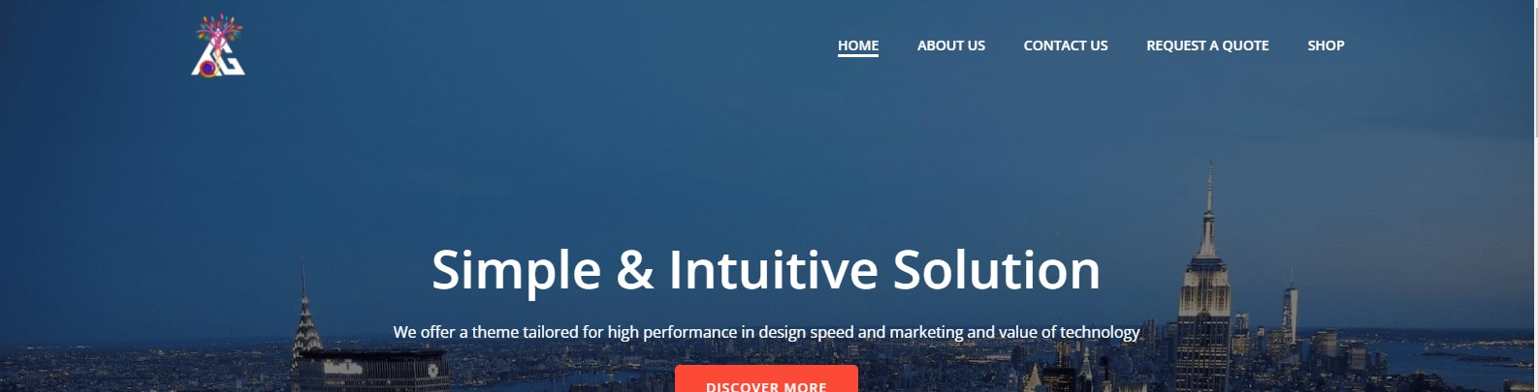

Overall early experience of the website is like the images shown below on pressing the below mentioned buttons all looked alike but now they seem well

First of all, discussing problems faced in the above section

* The Home button is working fine
* Early Experience was that when i press the( about us button )and( request a quote button) the forms don’t show up properly organized like the other two forms of (contact us and shop button)
* (About us button) was experiencing the same problem

Below are the screenshots of the problems mentioned

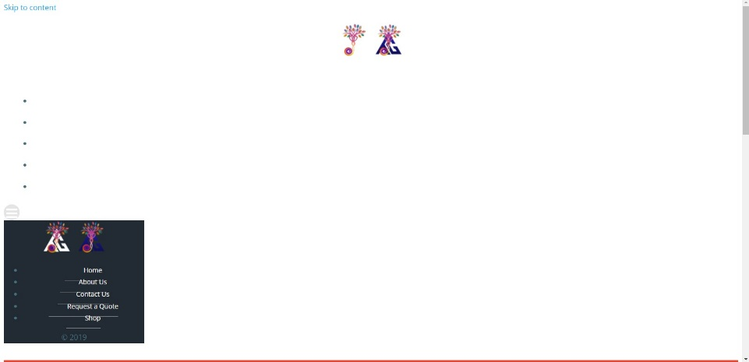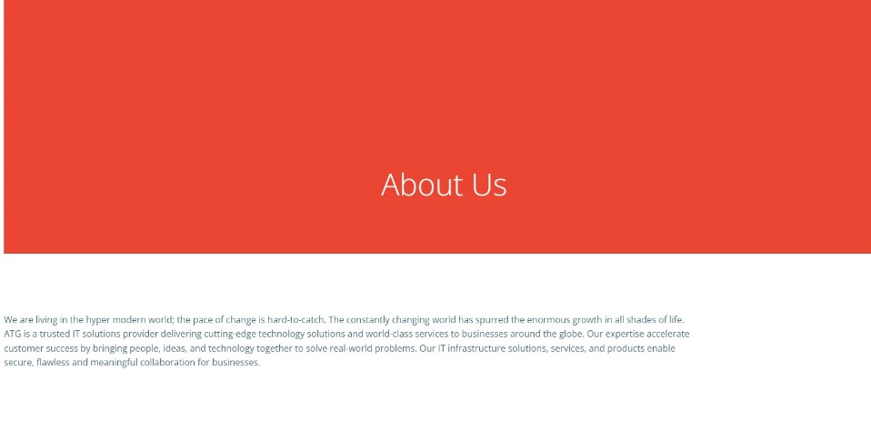

* Now the (request a quote button) and after a minute of opening the website is working fine
* Shop button as well all the buttons inside it are working completely fine, the forms show up perfectly
* Now underneath the company portfolio this line shouldn’t be there (Lorem ipsum dolor sit amet, at mei dolore tritani repudiandae. In his nemore temporibus consequuntur, vim ad prima vivendum consetetur.)

**Below is the screenshot of the problem seen**



* Now experiencing another problem that is these 6 forms don’t take us anywhere

They just refresh the whole webpage



* The Number of requests that the website can handle in a 30 second interval are

10 Minutes later experience

All forms are organized properly and appear properly on staying on the website and staying there for almost 10 minutes

The Website showed some stability issues during early minutes of visiting it